Nutrition and Exercise

Nutrition

- Make sure each meal/snack has a healthy amount of protein
- Eat fewer processed foods
- Choose local
- Choose colorful
- Pay attention to patterns between food and focus/mood

Food Journal – track what you ate and how you felt after eating it (i.e., heavy, energized, etc.)

Monday | Tuesday | Wednesday | Thursday | Friday | Saturday | Sunday

Exercise

Exercise for Focus – high-intensity workouts increase the flow of blood to the brain which helps with focus and helps to stabilize mood.

 | Monday | Tuesday | Wednesday | Thursday | Friday | Saturday | Sunday
I felt …
During my exercise, I was able to focus …
During the day, after my exercise, my focus was (better/worse)…
At night, after my exercise, my sleep was effected (+/-)…

The pages below include ideas for types of workouts that you may find beneficial.

The Scientific 7-Minute Workout
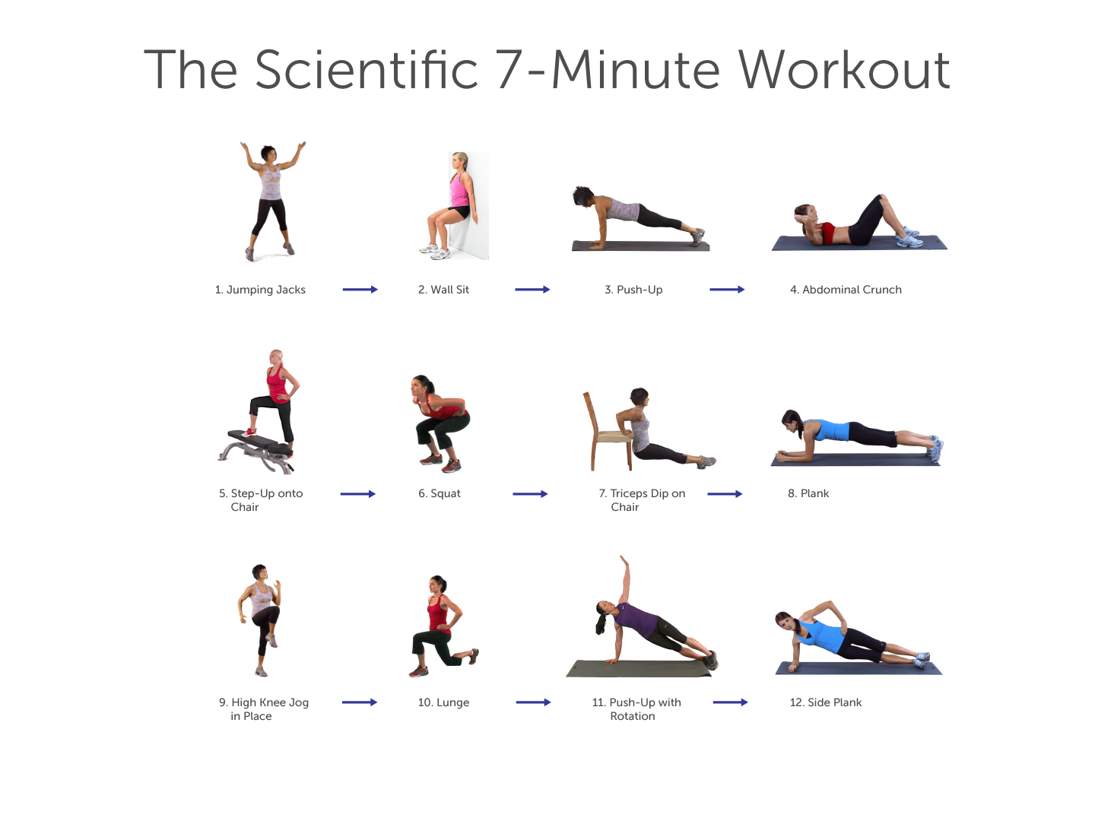

(Video: https://www.youtube.com/watch?v=Jru5B044HOs)

Tabata Training Intervals
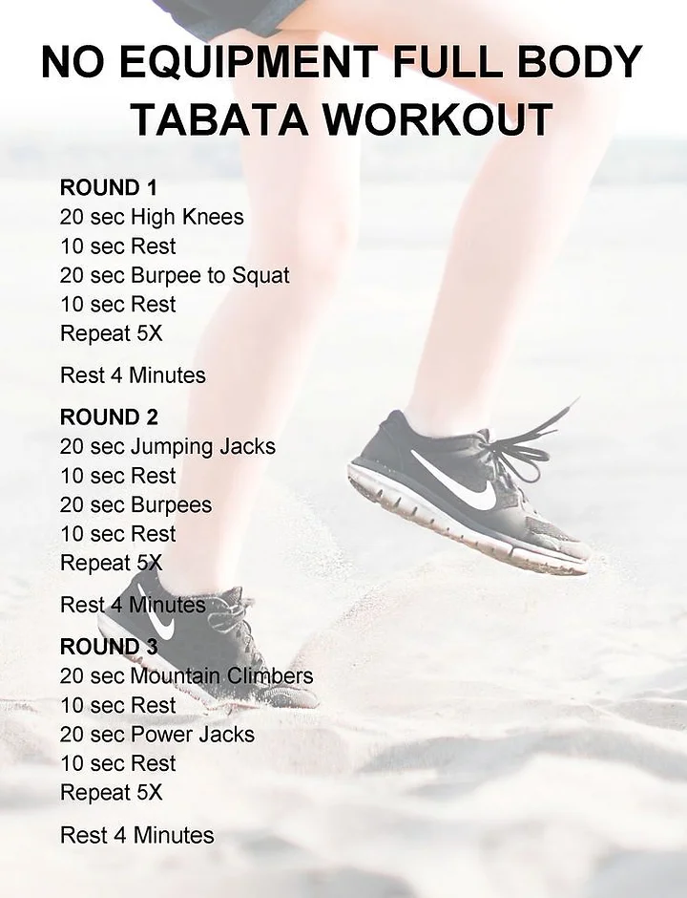
(Source: https://www.columbusymca.com/post/no-equipment-full-body-tabata-workout)

HIIT Academy 18-Minute HIIT Workout
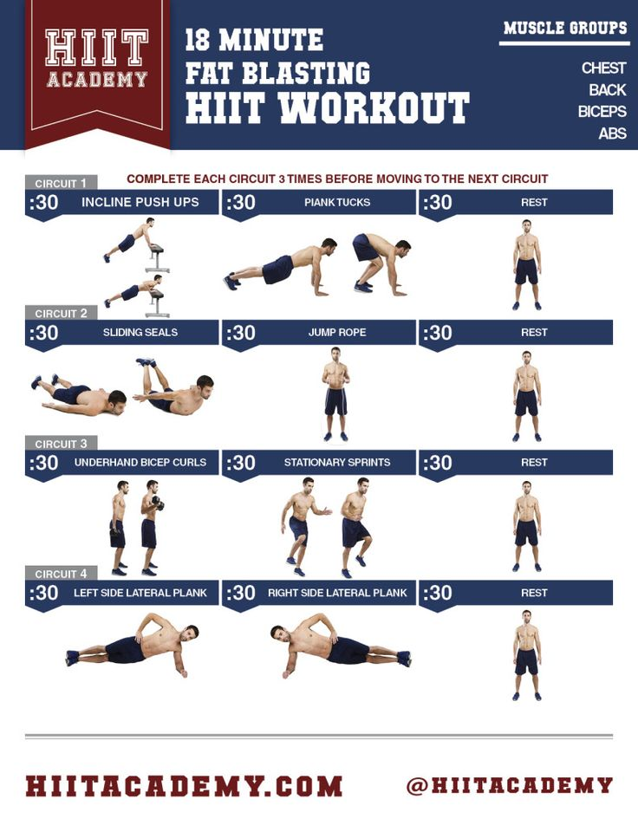(Source: https://www.acetutors.com.sg/test/apacheasp/The-Science-Behind-HIIT-And-Variations-Of-It-Tabata)

